**P1 – Explain how computer network’s communicates.**

**Computer Network**

**Computer Networks** is a combination of nodes – computers, printers, laptops- that is connected with each other and can transmit data with each other. They are different types of networks, which are WAN; LAN; PAN; MAN and VAN. I am going to be talking about LAN.

[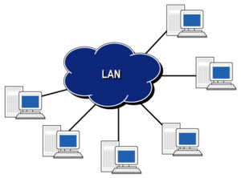](http://www.google.co.uk/url?sa=i&rct=j&q=&esrc=s&frm=1&source=images&cd=&cad=rja&docid=B3QSgsctIb3yZM&tbnid=UDAYmes2XCD-vM:&ved=0CAUQjRw&url=http://www.hill2dot0.com/wiki/index.php?title=Local_area_network&ei=tx3ZUv_7AcSb0QXz7ID4CQ&bvm=bv.59568121,d.ZG4&psig=AFQjCNGJrlBRqrrqylCLe3DDZRiTNyK4bQ&ust=1390047012440464)**LAN** stands for local area network. It says in the name ‘local’. LAN can be used for colleges, schools, universities. The advantages for LAN is that the local area network set up is cheap. In addition, users can transfer data easily. The connection should be relatively fast as they are all connected to the same network. If one workstation crashes or the network does not work, others will not be effected. On the other hand, the disadvantage for LAN is in every problem for network. The security for network is a real problem. Once a person finds out the password that is set for the network, they could get access with all the information that is shared. If the password is successful, it could do a lot of damage to the whole network system. Both workstations need to be switched on in order to transfer data. Figure 1.2 shows the diagram on LAN. This is different to WAN because LAN is just used for a local area, whereas WAN covers as much as a country.

Figure 1.2

LAN computers within a network are connected with the same connection. Therefore, they can communicate with another person easily depending on how fast the network is. LAN allows the user to communicate with the network by sending emails with another person. Obviously, they are barriers of it by delaying the message. It can enable communication with the printer as it can be connected by wire or wirelessly. Once it is connected, the user commands it to print the document. The message goes to the printer and printing the document is enabled.

**Network cards**

**Ethernet card**

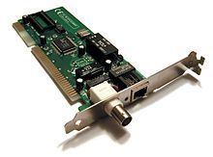Ethernet card is commonly known as Network Interface Cards. This is used for communication in a computer across the internet for the IOS diagram. It is used in the data-link layer and physical layer. It is required for them layers to enable communication. It is on each computer connected onto the motherboard.

**Network Topologies**

**Network topologies** means it is designed specifically geometrically by transferring data, including nodes. Nodes can be computers, printers and servers. They are different types of network topologies, which are the following:

* **Linear Bus**
* **Star**
* **Ring**
* **Mesh**
* **Tree**

Figure 1.6

* **Hybrid**

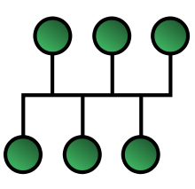**Bus** topology has a backbone where all the computers are connected to it. Figure 1.6 demonstrates the backbone where all the computers are connected to it. The advantages for using Bus topology is that it costs less. This is easy to set up and the extent of the network could be huge. In addition, it is good for local area network (LAN) because it is used for small networks such as LAN. There is a lot of dependency on the main cable. The problem with that is if the main cable comes across some problems, it could affect the whole network. Also, there is a limit to number of nodes that could be connected to this network.

[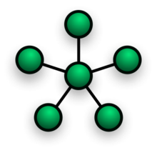](http://en.wikipedia.org/wiki/File:NetworkTopology-Star.png)**Star Topology** is all the nodes have been connected to one individual computer. Therefore, this becomes a shape as a star as that is where it got its name from. A star topology is commonly used in homes and offices. This is one of the popular topologies. The advantage of using star topology is that it is installed quickly. As it is connected to a central hub, the performance doesn’t affect other computers because it is not connected to them. Therefore, replacing any nodes is very easy as you are not disturbing any other computers. In addition, if any problems occur, the central hub will pick it up and it will be traced easily of which node is the problem. On the other hand, if the central hub’s servers are slow, it would affect the performance of the other computers. It takes a lot of cables to set up the network. Referring to Figure 1.5, it shows how star topology looks like. As you can see, all the computers are connected to one computer.

Figure 1.5

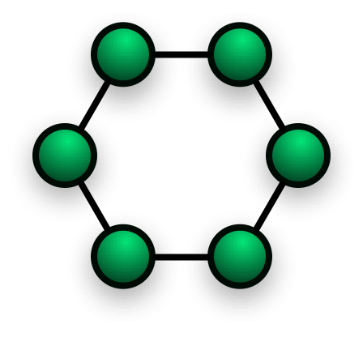**Ring** is a topology that has nodes (workstations or other devices) that are connected with each other as they makes a sphere ‘ring’. The advantage of using ring network topology is that data is transferred very quickly, but it must be passed through all the computers to reach to the receiver. If any node fails, any sender cannot receive any data as it will be interrupted with the failed node. To add another node between the rings, you must shut all the nodes down temporarily for the cabling to occur. Again, this is as same as any node failing. If the node is not switched on, data cannot be passed as it needs to pass through all the nodes to receive to the node. Referring to Figure 1.7, this shows us how ring topology looks like. The green dots could be represented as nodes.

Figure 1.7

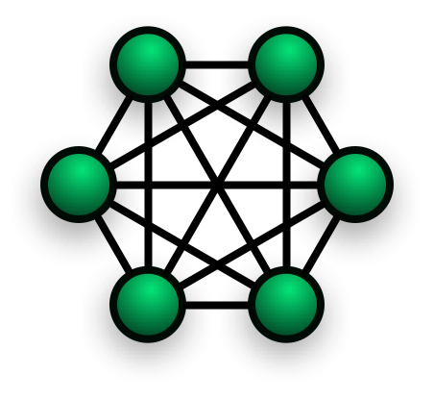**Mesh** is a topology has many connections in between the nodes. It looks similar to Ring topology but has connections in between. They are two different types of Mesh topology; full mesh and partial mesh. Full mesh has every node connected to each other whereas partial mesh has one or two nodes connected. The disadvantage for Mesh is that depending on how many nodes are connected with each other, it costs either more or less. Without disrupting nodes, expansion can be made easily. As they are many connections and cables between these networks, it is very hard to set up. Referring to Figure 1.8, this shows how a Mesh network could look like.

Figure 1.8

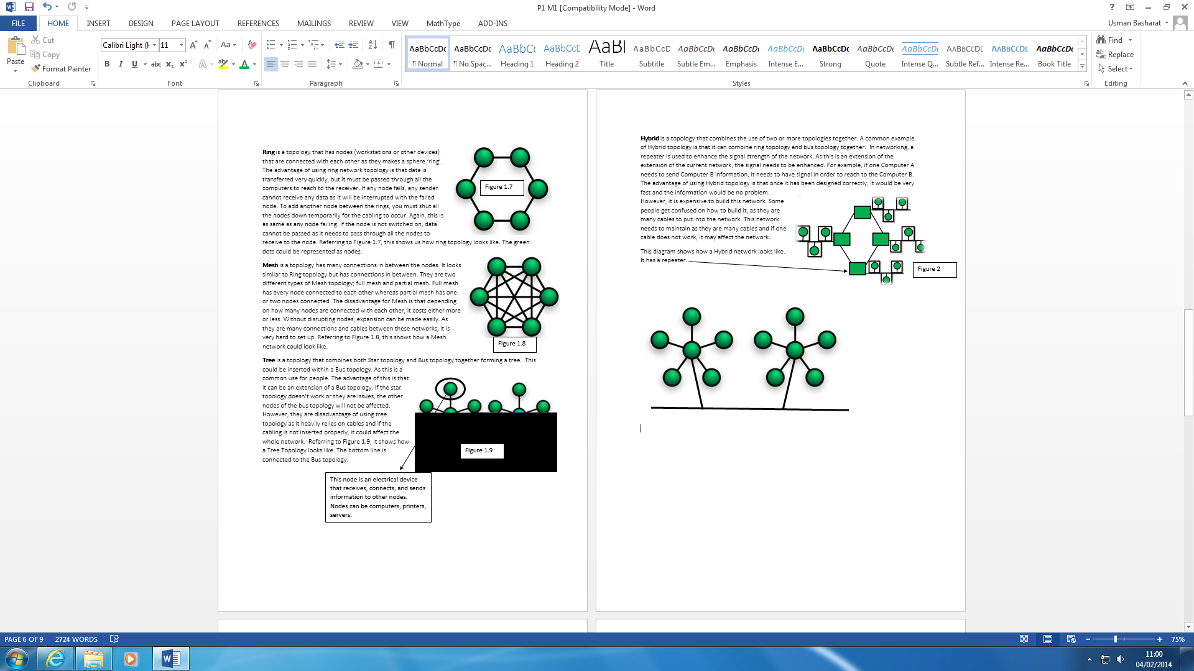**Tree** is a topology that combines both Star topology and Bus topology together forming a tree. This could be inserted within a Bus topology. As this is a common use for people. The advantage of this is that it can be an extension of a Bus topology. If the star topology doesn’t work or they are issues, the other nodes of the bus topology will not be affected. However, they are disadvantage of using tree topology as it heavily relies on cables and if the cabling is not inserted properly, it could affect the whole network. Referring to Figure 1.9, it shows how a Tree Topology looks like. The bottom line is connected to the Bus topology.

This node is an electrical device that receives, connects, and sends information to other nodes. Nodes can be computers, printers, servers.

Figure 1.9

**Each of these topologies communicate in the same way. All of these topologies transfers information through a token pass. If the information has been sent from COMP A and it needs to be sent to COMP E, it will need to go through all the computers in order for it to work. Obviously, they are laid-out different. However, the concept of it is the same.**

**Network Components**

**Workstations**

Workstations is a desktop computer that typically is networked used in a professional workplace or in a business. Workstations communicate with each other by using servers. Workstations is the main/first device that enables communication. An example for communication, the COMP A sends a message to COMP B. It goes through the network and tracks the IP address for it to send the message to enable communication. Workstations is not your local computer. It has:

* More cables
* Faster

It uses many cables for it to be connected to use the internet. A commonly found device that is connected to a network infrastructure. The term workstation has changed during the years. The aim of a workstation is to connect users to other users around the whole wide world. These workstations are run on an operating system e.g. Windows, Linux or MAC OS. The aim of using an operating system is to allow users to get access from another computer but the same place. An example of a workstation could be a computer. Nowadays, workstations can be used as a handheld phone:

* PDA
* Blackberry
* PSP

**Server**

Server could be a computer system that manages, responds or helps other users from a network service. Servers could be run on a computer. The server is the base of communication with the workstation. It enables servers for any type of communication. It could be email server. This enables other workstations (and other servers) to offer a dedicated server to them. The hosting server is the manager of the server. He only can access to all the materials, which other workstations cannot access. Some of the servers you may come across are:

* Chat and discussion servers
* Game clan management servers e.g. Minecraft
* [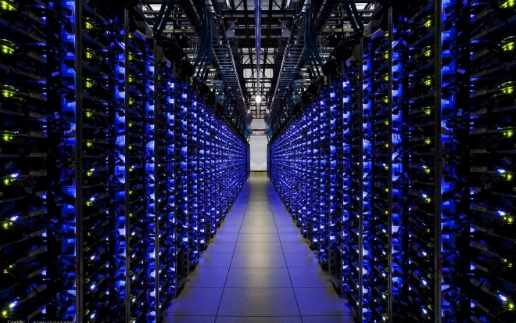](http://www.google.co.uk/url?sa=i&rct=j&q=&esrc=s&frm=1&source=images&cd=&cad=rja&uact=8&docid=Iy-akGclrhlxgM&tbnid=OWcrsrW78v5UkM:&ved=0CAYQjRw&url=http://infiniox.com/cloud-servers-registered-until-2017-for-infiniox-com/&ei=mPomU6sY04OFB7ePgTg&bvm=bv.62922401,d.ZG4&psig=AFQjCNHBCAX2HAj3P_LrNUB3muLal4r48Q&ust=1395149840452732)Security servers
* Web servers

Some of the servers have requirements that you may need to get access to the server. For example, when you want to play Minecraft, you have to be connected with the internet for you to play with others. This is important, as having an internet connection is one of the main requirements. Referring to Figure 1.1, it demonstrates how the Cloud server looks like. It has many cables and devices for it to be connected.

Figure 1.1

**Interconnection device**

**Wireless Access Point (WAP)**

A wireless access point allows accessing the network wirelessly. It acts like a centralised source that transmits data and receives it. They are no cables involved. Therefore, the purpose of a wireless access point is to transfer data without using cables. More than one user can connect, but it has a range. If you are close to the access point (AP), you will transfer data faster. The more you move away from the AP, it is likely you might get disconnected. This is where communication is enabled. If the user is within the range of the distance, the user will enable communication with the network. The features of a wireless access point is that it can connect many devices at once. Obviously, the connection might be slow but if the user uses it at the right time, it may enable fast activity. It can connect laptops, desktop PCs, tablets, printers and mobile phones. The role of a wireless access point is that it mainly acts as switches to spread connections wirelessly. They only lock out traffic that does not have the wireless code.

**Network Software**

**Operating System**

An operating system is a software that is a baseline support, which a computer requires for it to work. An example could be Windows. They are many basic support lines that the operating system does. This is distinctive with other operating system e.g. Linux and Windows. The user sharing the documents, files and videos enables communication within an operating system. This allows the user to communicate as they can gain access with the shared document. For example, in LSC, we have a studentshare. Every person gains access to it if the file is shared. Working frameworks regularly, give intends to secure Internet associations. Case in point, Windows Vista naturally designs some broadband Internet associations when you associate with the broadband line.

**Network Connection Software**

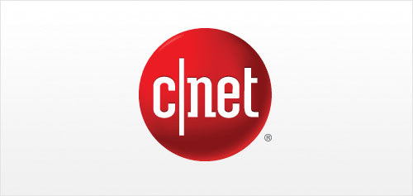Network Connection Software is held within the operating system. The operating system is the first one and network connection software branches off it. This is a network that ensures the connectivity within a network. It monitors the computer’s bandwidth and ensures that you are always online. It is held within every computer from the computers at homes to the largest networks in any organisation. An example of network connection is CNET that is used for computers that can enable communication to maintain the network connectivity.

**Access methods**

**Token Passing**

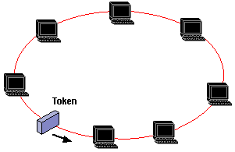Token passing is a communication protocol that is used in telecommunication. The token is a ‘message’ that is sent from one computer to another. Only one of the device sends it to another which enables communication. The device has to wait for it to be sent to the computer to enable communication with each other. An example of token passing is token ring and ARCNET. As the image presents how the token passing is being presented.

**Network services**

**ATM**

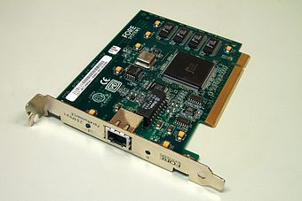Asynchronous Transfer Mode is a service that does many tasks for telecommunication network including voice, data and video. ATM uses Time-Division Multiplexing (TDM). TDM is a method of transmitting and receiving data for telecommunication. It was developed in the late 1800s. An example that uses ATM could be Skype. It has voice, data and video communication methods for ATM to be used.

**Reference**

BTEC Book page: 314- 315, 316-317

<http://quizlet.com/13365480/unit-1-understanding-how-networks-communicate-flash-cards/>

<http://ictsmksh.blogspot.co.uk/2010/07/introduction-to-computer-networks-and.html>

<http://users.telenet.be/mydotcom/library/network/netintro.htm>

<http://www.pctecmech.com/networking/How-Do-Computers-Communicate.php>